**Lab Task(s):**

1. **Write a query to display EMPLOYEE_ID, FIRST_NAME, and SALARY of employees whose SALARY is less than $3000.**

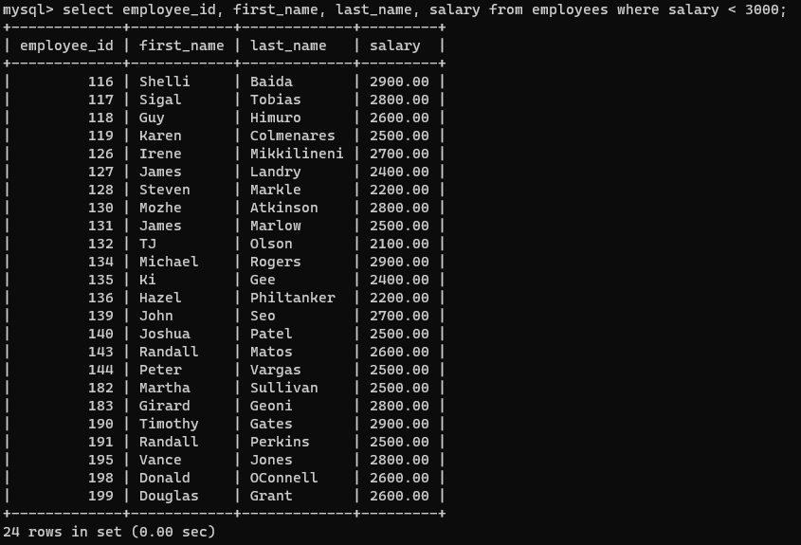

1. **Write a query to display FIRST_NAME, LASTNAME of all employees whose first name starts with letter ‘A’.**

1. **Write a query to display FIRST_NAME, JOB_ID, DEPARTMENT_ID of employees who are either PU_CLERK or belongs to MANAGER_ID = 114.**

1. **Write a query to display EMPLOYEE_ID, FIRST_NAME, and SALARY of employees whose salaries lies in the range of $1500 to $3000;**

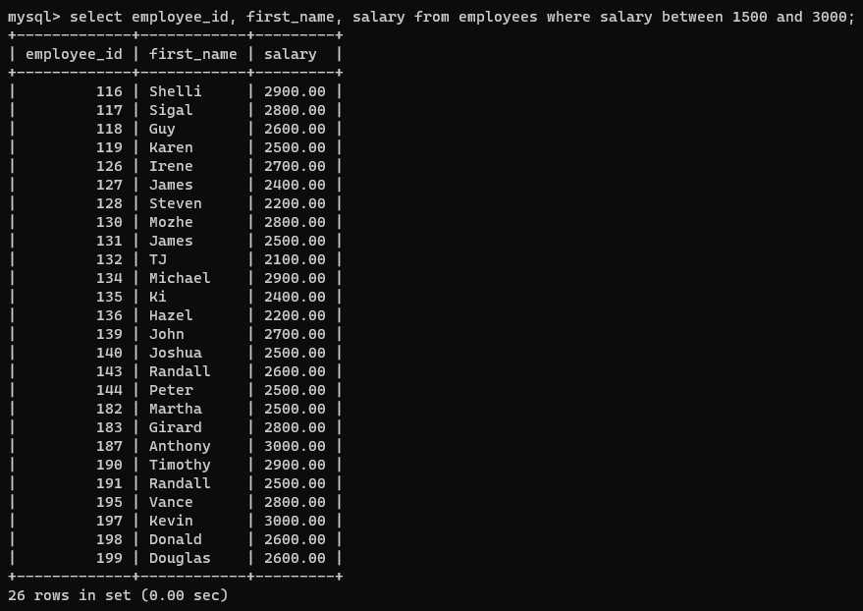

1. **Write a query to display EMPLOYEE_ID, FIRST_NAME, and SALARY of employees whose commission is empty.**

1. **Write a query to display first names of all employees that end with alphabet ‘N’.**

1. **Write a query to display FIRST_NAME, JOB_ID, DEPARTMENT_ID of employees who are not PU_CLERK.**

1. **Write a query to display EMPLOYEE_ID, FIRST_NAME, and SALARY of those employees who do not have salaries of $3300, $3200, $2200.**

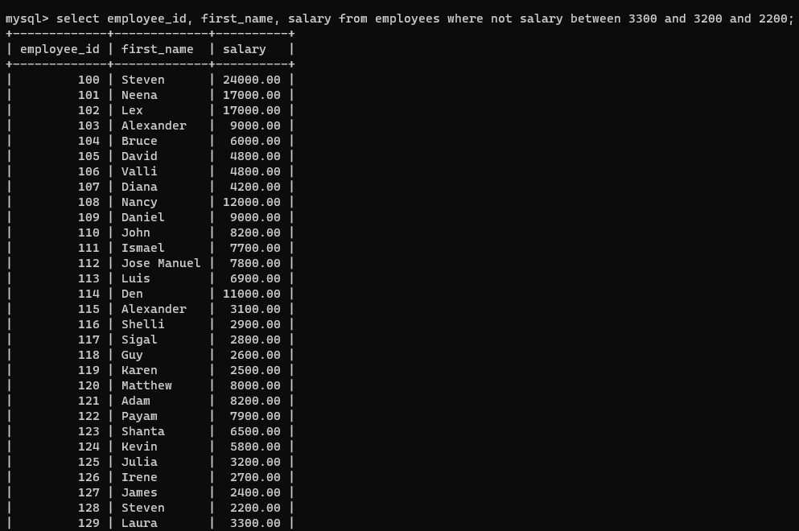

1. **Write a query to display names of those employees whose first name starts with ‘A’ and ends with ‘N’.**

1. **Write a query to display the list of employee names that have letters ‘LA’ in their names.**

1. Write a query to display the EMPLOYEE_ID, FIRST_NAME, and SALARY of employees. In that, the highest paid employee should display first and lowest paid should display last.A picture containing text

   Description automatically generated
2. **Write a query to display FIRST_NAME of employees that have "a" in the second position.**

1. **Write a query to display EMPLOYEE_ID, FIRST_NAME, and SALARY of employees whose salaries do not lies in the range of $1500 to $3000;**

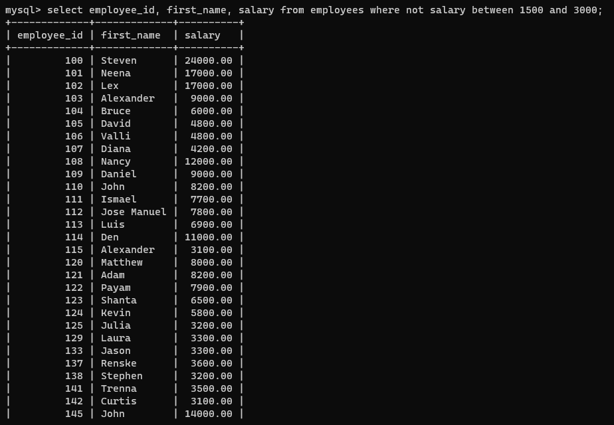

1. **Write a query to display FIRST_NAME, LAST_NAME and DEPARTMENT_ID of all employees in departments 30 or 100 in ascending order.**

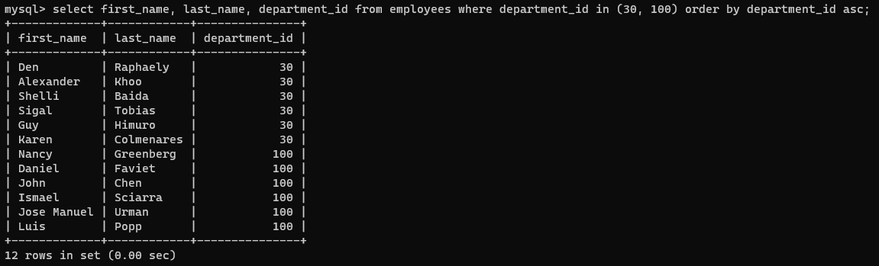

1. **Write a query to display FIRST_NAME, LAST_NAME and SALARY for all employees whose salary is not in the range $10,000 through $15,000 and are in department 30 or 100.**

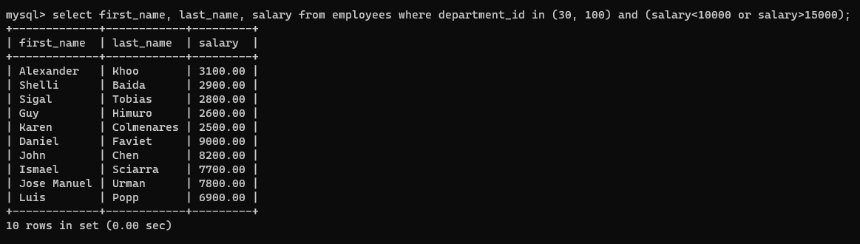

1. **Write a query to display FIRST_NAME, LAST_NAME and HIRE_DATE for all employees who were hired in 1987.**

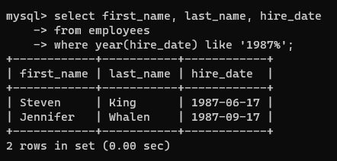

1. **Write a query to display the LAST_NAME of employees whose LAST_NAME have exactly 6 characters.**

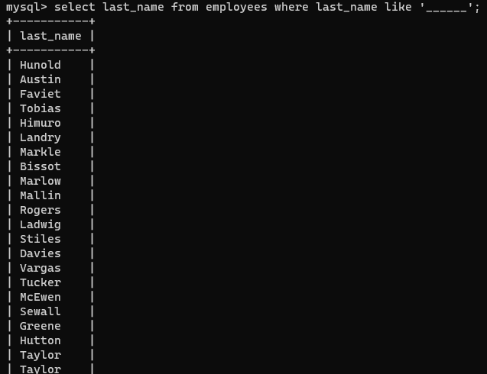

1. **Write a query to display FIRST_NAME, SALARY and PF (15% of salary) of all employees.**

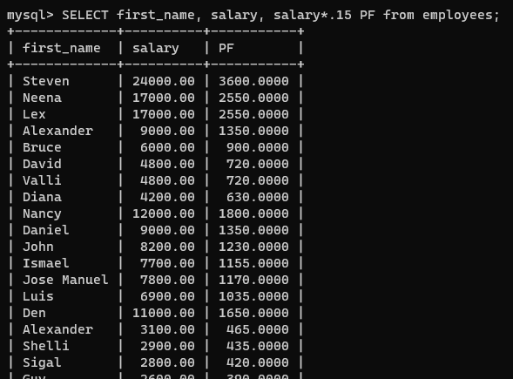

1. **Write a query to display FIRST_NAME, SALARY and commission amount (% of salary) of all employees.**

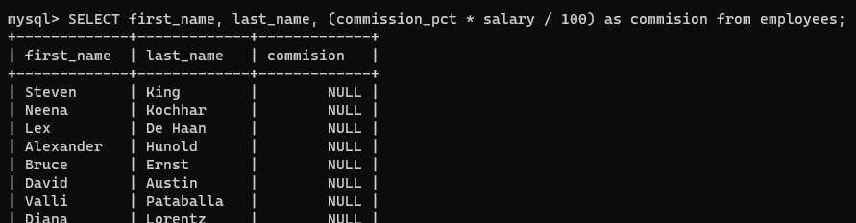

1. **Write a query to display FIRST_NAME, SALARY and NET_SALARY after 500 deductions from salary of all employees;**

